**FRIO COUNTY COMMISSIONERS COURT MINUTES FOR**

**Regular Meeting May 9TH, 2023**

On the 9th day of May, 2023, at 3:00 p.m., the Commissioners Court of Frio County met in a regular meeting with the following members either absent or present, to-wit: Rochelle Lozano Camacho, Frio County Judge was absent; Joe Vela, Commissioner Pct 1 absent; Mario Martinez, Commissioner Pct 2 present; Raul Carrizales, Commissioner Pct 3 present; Danny Cano, Commissioner Pct 4 present; Joseph A. Sindon, Legal Counsel for Frio County Commissioners Court present; and Aaron Ibarra, Frio County Clerk present when the following meeting was held, to-wit:

I. Invocation and Pledge of Allegiance

II. Adopt Agenda

**MOTION: COMMISSIONER MARTINEZ**

**SECOND: COMMISSIONER CANO**

**MOTION PASSED**

III. Old Business

**PRESENTATION**

**ACTION AGENDA ITEMS**

IV. General Discussion- **SHERIFF MIKE MORSE RECOGNIZED HIS DETENTION STAFF FOR THEIR EXCELLENT WORK AND DUE DILLIGENCE.**

V. Citizens To Be Heard- **MR. GONZALES SPOKE FOR THREE MINUTES ABOUT A PROBLEM HE IS HAVING WITH 18 WHEELERS PARKING AND DESTROYING THE ROADS NEAR AND AROUND HIS PROPERTY.**

VI. New Business

**PRESENTATION**

**ACTION AGENDA ITEMS**

(1) Hon. Pete Jasso Martinez, Frio County Treasurer, requests:

1.1 Consider/take action on opening bid proposals for depository contract for Frio County.

1.2 Consider/take action on accepting a deposit bid for Frio County beginning June 1, 2023 ending on May 31, 2025.

**MOTION: COMMISSIONER MARTINEZ**

**SECOND: COMMISSIONER CANO**

**MOTION PASSED**

(2) Hon. Rochelle Camacho, Frio County Judge, requests:

Consider/take action on proclaiming May 2023 as Community Action Month and approve and sign proclamation stating same.

**MOTION: COMMISSIONER MARTINEZ**

**SECOND: COMMISSIONER CANO**

**MOTION PASSED**

(3) Hon. Rochelle Camacho, Frio County Judge, requests:

Consider / take action on running a sealed request for proposals (RFP) ad (below) in the Frio Nueces Current once a week for two weeks pursuant to Local Government Code Sec. 262.025.  The ad will run in the Frio-Nueces Current on May 11, 2023 and May 18, 2023. Sealed RFP’s will be accepted in the Auditor’s office until 3:00 pm, May 26, 2023.  RFP’s will be opened during commissioner’s court on May 30, 2023.

**REQUEST FOR PROPOSALS**

**Frio County**

Frio County is soliciting planning and management service providers to assist the with the development of a new or updated Hazard Mitigation Action Plan. If awarded with funding, CDBG-MIT LHMPP Frio County funds will be administered by HUD and implemented through the Texas General Land Office fund. These planning activities, and the Hazard Mitigation Plan development and approval oversight is administered by FEMA and implemented through the Texas Division of Emergency Management (TDEM). Accordingly, Frio County seeks to contract with a qualified service provider for planning and management services. Please electronically submit your proposals in .pdf format via email at frioemc@friocounty.org **or** submit 6 copies of your proposal of services to the following address: Frio County, Attn: Ray Kallio, 101 N. Commerce St., Ste. 111, Dilley, TX 78017. Proposals must be received by Frio County no later than 4:00 p.m., June 22, 2023 to be considered. Frio County reserves the right to negotiate with any and all proposers, as per the Texas Professional Services Procurement Act and the Uniform Grant and Contract Management Standards. Minority Business Enterprises, Small Business Enterprises, Women Business Enterprises, and labor surplus area firms are encouraged to submit proposals. Frio County is an Affirmative Action/Equal Opportunity Employer. Servicios de traducción están disponibles por peticion.

**MOTION: COMMISSIONER MARTINEZ**

**SECOND: COMMISSIONER CANO**

**MOTION PASSED**

(4)  Hon. Raul Carrizales, III, Frio County Commissioner.  Precinct No. 3, requests:

Consider/take action on approving the county to pay Trevino Royal Oaks Funeral Chapels for the indigent cremation of Eusevio Martinez Jr.

**MOTION: COMMISSIONER CARRIZALES**

**SECOND: COMMISSIONER CANO**

**MOTION PASSED**

**IT WAS NOTED THAT AN INVOICE IS NEEDED, AND THE AGREED UPON NUMBER WAS $411.00**

(5) Hon. Crystal Marquez, Frio County Auditor, requests:

Consider / take action on approving Judge Camacho to sign LOR with 5 to solicit electricity rates on behalf of Frio County, due to the upcoming expiring electricity contract.

**MOTION: COMMISSIONER MARTINEZ**

**SECOND: COMMISSIONER CANO**

**MOTION PASSED**

(6) Hon. Crystal Marquez, Frio County Auditor, requests:

6.1 Consider / take action on approving Service Order with Spectrum Enterprise for Spectrum Business Services for the location of 407 S. Pecan St. Pearsall, Texas.

6.2 If the Service Order is approved, consider/take action on approving a resolution authorizing Hon. Rochelle Camacho, Frio County Judge, to sign same on behalf of Frio County.

**MOTION: COMMISSIONER CANO**

**SECOND: COMMISSIONER MARTINEZ**

**MOTION PASSED**

(7) Hon. Crystal Marquez, Frio County Auditor, requests:

7.1 Consider / take action on approving Security Light Agreements with Medina Electric for installation of security lights on CR 4603 & CR 4604, and IH 35 & CR 4602 in the Hilltop Subdivision in Dilley, Texas.

7.2 If the application is approved, then approve and sign a resolution authorizing Hon. Rochelle Camacho, Frio County Judge, to execute the application on behalf of Frio County.

**MOTION: COMMISSIONER CANO**

**SECOND: COMMISSIONER MARTINEZ**

**MOTION PASSED**

(8) Hon. Crystal Marquez, Frio County Auditor, requests:

8.1 Consider / take action to approve the budget amendments to the FISCAL YEAR 2022-2023 Frio County Budget, list below:

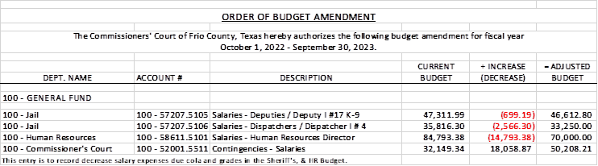

8.2 If the amendment is approved, consider/take action on signing order stating same.

**MOTION: COMMISSIONER CARRIZALES**

**SECOND: COMMISSIONER MARTINEZ**

**MOTION PASSED**

(9) Hon. Crystal Marquez, Frio County Auditor, requests:

9.1 Consider / take action to approve the budget amendments to the FISCAL YEAR 2022-2023 Frio County Budget, list below:

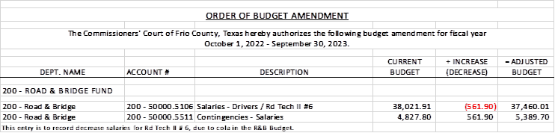

9.2 If the amendment is approved, consider/take action on signing order stating same.

**MOTION: COMMISSIONER MARTINEZ**

**SECOND: COMMISSIONER CANO**

**MOTION PASSED**

(10) Hon. Crystal Marquez, Frio County Auditor, requests:

10.1 Consider / take action to approve the budget amendments to the FISCAL YEAR 2022-2023 Frio County Budget, list below:

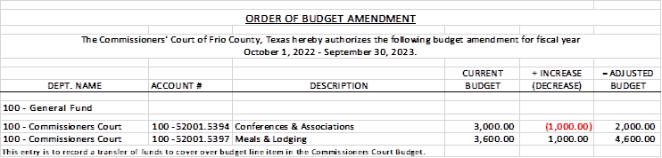

10.2 If the amendment is approved, consider/take action on signing order stating same.

**MOTION: COMMISSIONER MARTINEZ**

**SECOND: COMMISSIONER CANO**

**MOTION PASSED**

(11) Ancelmo Ornelas, Frio County Road and Bridge Administrator, requests:

Consider/take action on waiving the park fees for an annual fundraiser to be held on September 16, 2023 at the BigFoot Park.

**MOTION: COMMISSIONER MARTINEZ**

**SECOND: COMMISSIONER CANO**

**MOTION PASSED**

(12) Ancelmo Ornelas, Frio County Road and Bridge Administrator, requests:

12.1 Consider/take action on approving and adopting resolutions granting permits to Pilot Water Solutions, SDW LLC to lay bore, construct and maintain one (1) eight-inch (8”) polypropylene pipe water line enclosed in a one (1) twelve-inch (12”) steel casing under the County Road 4899 Road right-of-way for a total permit fee of $150.00.

12.2 If the resolution is approved and adopted, then authorize Frio County Judge Rochelle Camacho to execute the permit on behalf of Frio County, Texas to Pilot Water Solutions, SDW LLC.

**MOTION: COMMISSIONER MARTINEZ**

**SECOND: COMMISSIONER CANO**

**MOTION PASSED**

(13) Hon. Rochelle Camacho, Frio County Judge, requests:

Consider/take action on approving the county to pay Trevino Royal Oaks Funeral Chapels for the indigent cremation of Randal Porter.

**MOTION: COMMISSIONER CANO**

**SECOND: COMMISSIONER MARTINEZ**

**MOTION PASSED**

**LET IT BE NOTED THAT THE AGREED UPON NUMBER WAS $850.00**

(14) Hon. Danny Cano, Frio County Commissioner, Precinct No. 4, requests:

14.1 Consider/take action on entering into an Interlocal Agreement Between the Frio County and the City of Dilley for animal control services.

14.2 If the agreement is approved, consider/take action on approving a resolution authorizing Hon. Rochelle Camacho to sign same on behalf of Frio County.

**ITEM WAS REMOVED, TABLED.**

(15) Hon. Rochelle Camacho, Frio County Judge, requests:

15.1 Consider/take action on finding that circumstances present in all or part of the unincorporated areas of Frio County that create a public safety hazard that would be exacerbated by outdoor burning.

15.2 Consider/take action on adopting an Order of the Frio County Commissioners Court Prohibiting or Restricting Outdoor Burning in the Unincorporated Areas of Frio County, Texas from May 4, 2023 to August 2, 2023.

**NO ACTION**

(16) Frio County Commissioners Court, requests:

Receive in person from the following county officials the following reports as mandated by law:

16.1 Presentation by Frio County Treasurer of detailed report as mandated by Section 114.026, Local Government (“Code”) (this report is to be presented at each **regular term of commissioners court).**

16.2 Frio County Treasurer to exhibit the books and accounts of that office for the inspection of the commissioners court (**to be done at each regular term of commissioners court).**

16.3 Consider/take action on authorizing the execution by Frio County Commissioners Court (the Judge and each commissioner) of an affidavit stating the requirements of the treasurer’s report have been met as mandated by section 114.026 of the Code.

16.4 Consider/take action on execution of an order of the commissioners court approving the county treasurer’s report and order their publication in the Frio-Nueces Current as mandated by Section 114.026 of the Code or publication on the county’s website.

**MOTION: COMMISSIONER MARTINEZ**

**SECOND: COMMISSIONER CANO**

**MOTION PASSED**

(17) Frio County Commissioners Court requests:

Presentation, pursuant to Section 114.044 of the Local Government Code, by:

1. Frio County District Clerk;

2. Frio County Clerk

3. Frio County Treasurer

4. Frio County Attorney

5. Frio County Judge

6. Frio County Sheriff

7. Frio County Auditor

8. Frio County Justice of the Peace

9. Frio County Constables

**(who collects or handles any money for the use of the county) of all fines imposed, judgments rendered and collected, and all jury fees collected by the respected courts in favor of or for the use of the county and at that time when the reports are presented to present receipts vouchers that show disposition of the money, fines or judgments.**

After examination by the commissioners court as to the correctness of the reports, consider/action on directing the county clerk to enter information in county finance records as mandated by Section 114.044 of the Code.

**CONSTABLE 1, AND JUSTICE OF THE PEACE 4 MISSING**

**MOTION: COMMISSIONER CARRIZALES**

**SECOND: COMMISSIONER CANO**

**MOTION PASSED**

(18) Documents (resolutions, orders, contracts, etc.) to be signed.

**REVIEWED AND SIGNED**

(19) Allow bills payable

**MOTION: COMMISSIONER CARRIZALES**

**SECOND: COMMISSIONER MARTINEZ**

**MOTION PASSED**

**LET IT BE NOTED THAT THEY ADDED ON AN ADDITIONAL EXPENSE FOR $411.00 AND 850.00 FOR CREMATIONS APPROVED**

(20) Adjourn

**MOTION: COMMISSIONER CARRIZALES**

**SECOND: COMMISSIONER MARTINEZ**

**MOTION PASSED**

**APPROVED:**

**_____________________________________  
  
_____________________________________  
  
_____________________________________  
  
_____________________________________  
  
_____________________________________**